EX:NO:1 | ANDROID APPLICATION USING RELATIVE LAYOUTS
DATE:27-06-19

AIM:

Program for developing an Android Application using a Relative Layout

Description:

1)Open android studio and select new android project .
2)Give project name and select next
3) Choose the android version.Choose the lowest API 15:Android
4.3.0(IceCreamSandwish) and select next
4) Enter the package name.package name must be two word seprated by comma
and click finish
5)Go to package explorer in the left hand side.select our project.
6)Go to res folder and select layout.Double click the main.xml file
7)Now you can see the Relative layout window.

MAIN ACTIVITY:
package com.example. relativelayout;
import androidx.appcompat.app.AppCompatActivity;
import android.content.Context;
import android.os.Bundle;
import android.view.View;
import android.widget.Button;
import android.widget.TextView;
public class MainActivity extends AppCompatActivity {
@Override
protected void onCreate(Bundle savedInstanceState) {
super.onCreate(savedInstanceState);
setContentView(R.layout.relative);
final TextView textView=(TextView)findViewById(R.id.txt5);
Button button1 = (Button)findViewById(R.id.b1);
button1.setOnClickListener(new View.OnClickListener() {
public void onClick(View v) {
textView.setText("Successfully enrolled");
}
});
}
}

XML(activity):

<?xml version="1.0" encoding="UTF-8"?>

<RelativeLayout
android:layout_height="match_parent"
android:layout_width="match_parent"
android:background="#C3A1E1" xmlns:android="http://schemas.android.com/apk/res/android">

<TextView
android:layout_height="wrap_content"
android:layout_width="match_parent"
android:layout_marginTop="20dp"
android:gravity="center"
android:textStyle="bold"
android:textSize="40dp"
android:layout_marginRight="30dp"
android:layout_marginLeft="30dp"
android:text="Relative Layout"
android:id="@+id/r1"/>
<TextView
android:layout_height="wrap_content"
android:layout_width="wrap_content"
android:layout_marginTop="80dp"
android:textStyle="bold"
android:textSize="30dp"
android:layout_marginLeft="40dp"
android:text="Name"
android:id="@+id/txt2"
android:layout_below="@id/r1"/>

<EditText
android:layout_height="wrap_content"
android:layout_width="wrap_content"
android:layout_marginTop="80dp"
android:layout_marginLeft="200dp"
android:id="@+id/e1"
android:layout_below="@id/r1"
android:hint="Enter your name"
android:inputType="text"/>

<TextView
android:layout_height="wrap_content"
android:layout_width="wrap_content"
android:layout_marginTop="80dp"
android:textStyle="bold"
android:textSize="30dp"
android:layout_marginLeft="40dp"
android:text="Age"
android:id="@+id/txt3"
android:layout_below="@id/txt2"/>

<EditText
android:layout_height="wrap_content"
android:layout_width="wrap_content"
android:layout_marginTop="80dp"
android:layout_marginLeft="200dp"
android:id="@+id/e2"
android:layout_below="@id/e1"
android:hint="Enter your age"
android:inputType="number"/>

<TextView
android:layout_height="wrap_content"
android:layout_width="wrap_content"
android:layout_marginTop="80dp"
android:textStyle="bold"
android:textSize="30dp"
android:layout_marginLeft="40dp"
android:text="DOB"
android:id="@+id/txt4"
android:layout_below="@id/txt3"/>

<EditText
android:layout_height="wrap_content"
android:layout_width="wrap_content"
android:layout_marginTop="80dp"
android:layout_marginLeft="200dp"
android:id="@+id/e3"
android:layout_below="@id/e2"
android:hint="Enter your dob"
android:inputType="date"/>

<Button
android:layout_height="wrap_content"
android:layout_width="wrap_content"
android:layout_marginTop="50dp"
android:text="SUBMIT"
android:id="@+id/b1"
android:layout_below="@id/txt4"
android:layout_centerInParent="true"/>

<TextView
android:layout_height="wrap_content" android:layout_width="wrap_content"
android:textStyle="bold"
android:textSize="20dp"
android:layout_marginLeft="100dp"
android:id="@+id/txt5"
android:layout_below="@id/b1"/>

</RelativeLayout>

OUTPUT:

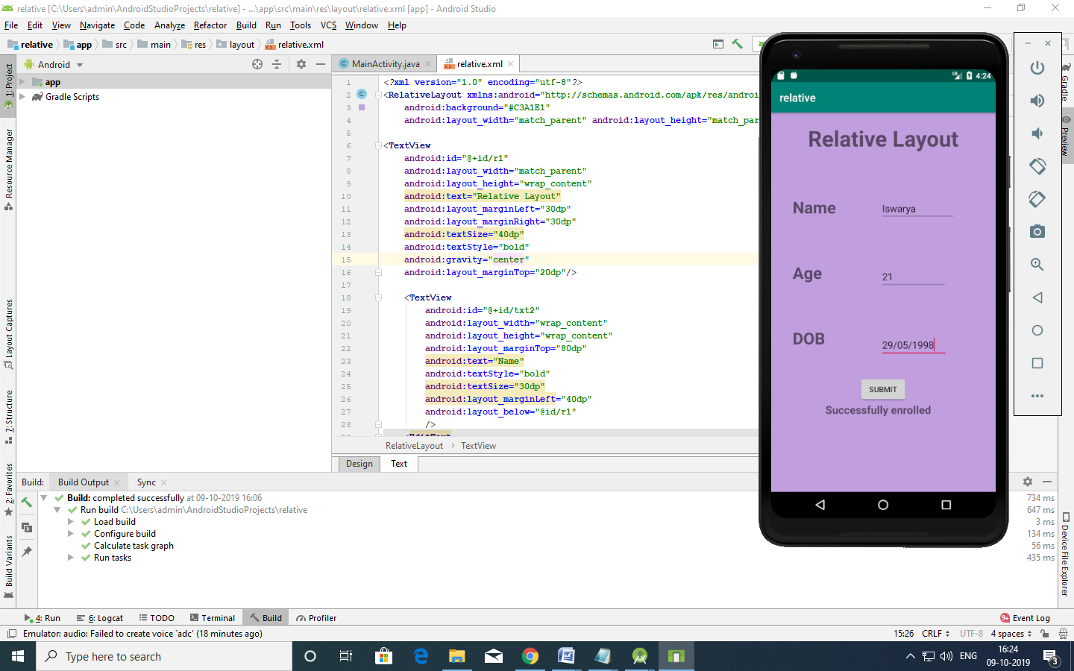

EX:NO:2 | ANDROID APPLICATION USING LINEAR LAYOUT.
DATE:05-07-19

AIM:

Program for developing an Android Application using a Relative Layout

Description:

1)Open android studio and select new android project .
2)Give project name and select next
3) Choose the android version.Choose the lowest API 15:Android
4.3.0(IceCreamSandwish) and select next
4) Enter the package name.package name must be two word seprated by comma
and click finish
5)Go to package explorer in the left hand side.select our project.
6)Go to res folder and select layout.Double click the main.xml file
7)Now you can see the Linear layout window.

XML(activity):

<?xml version="1.0" encoding="utf-8"?>
<LinearLayout xmlns:android="http://schemas.android.com/apk/res/android"
android:layout_width="fill_parent"
android:layout_height="fill_parent"
android:orientation="vertical">
<Button
android:id="@+id/mybutton"
android:layout_width="wrap_content"
android:layout_height="wrap_content"
android:text="M.C.A"
android:background="@color/colorAccent" />
<Button
android:id="@+id/mybutton1"
android:layout_width="wrap_content"
android:layout_height="wrap_content"
android:text="M.SC(CS)"
android:background="@color/colorPrimary" />
<TextView
android:id="@+id/textView1"
android:layout_width="wrap_content"
android:layout_height="wrap_content" />
</LinearLayout>

MAIN ACTIVITY:

package com.example.linearlayout;
import android.app.Activity;
import android.os.Bundle;
import android.view.View;
import android.widget.Button;
import android.widget.TextView;
public class MainActivity extends Activity {
@Override
public void onCreate(Bundle savedInstanceState) {
super.onCreate(savedInstanceState);
setContentView(R.layout.activity_main);
final TextView textView=(TextView)findViewById(R.id.textView1);
final Button button1 = (Button)findViewById(R.id.mybutton);
final Button button2 = (Button)findViewById(R.id.mybutton1);
button1.setOnClickListener(new View.OnClickListener() {
public void onClick(View v) {
textView.setText("Succesfully Enrolled MCA");
} });
button2.setOnClickListener(new View.OnClickListener() {
public void onClick(View v) {
textView.setText("Succesfully Enrolled MSC");
} });
}
}

OUTPUT:

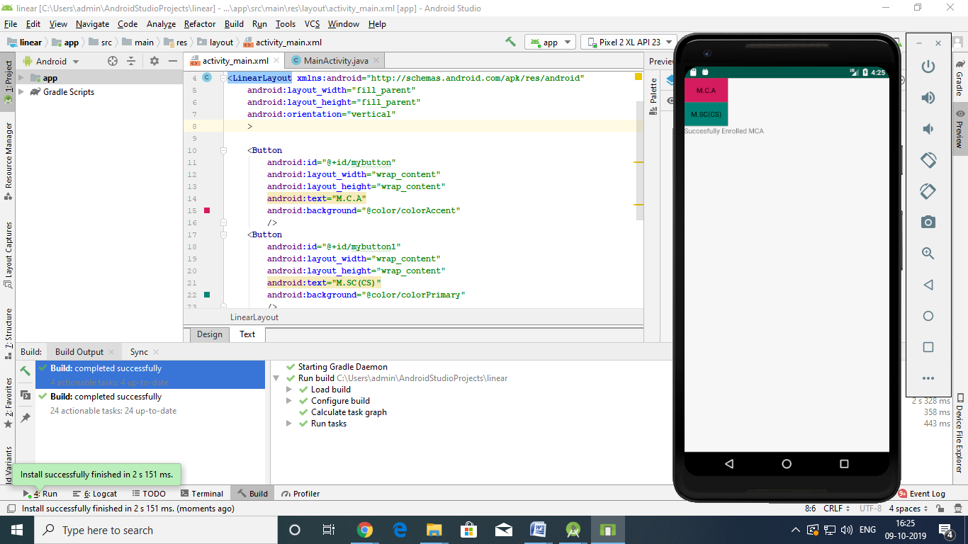
EX:NO:3 | IMPLEMENTATION OF GUI
DATE:19-07-19

AIM:

Program for developing an Android Application using a GUI

Description:
1)Open android studio and select new android project .
2)Give project name and select next
3) Choose the android version.Choose the lowest API 15:Android
4.3.0(IceCreamSandwish) and select next
4) Enter the package name.package name must be two word seprated by comma
and click finish
5)Go to package explorer in the left hand side.select our project.
6)Go to res folder and select layout.Double click the main.xml file
7)Now you can see the Graphics layout window.

MAIN ACTIVITY:

package com.example.gui;

import androidx.appcompat.app.AppCompatActivity;

import android.os.Bundle;
import android.graphics.Color;
import android.graphics.Typeface;
import android.view.View;
import android.widget.Button;
import android.widget.TextView;

public class MainActivity extends AppCompatActivity {
float font=24;
int i=1;
@Override
protected void onCreate(Bundle savedInstanceState) {
super.onCreate(savedInstanceState);
setContentView(R.layout.activity_main);
final TextView t1 = (TextView) findViewById(R.id.textview1);
Button b1 = (Button) findViewById(R.id.button1);
b1.setOnClickListener(new View.OnClickListener() {
@Override
public void onClick(View view) {
t1.setTextSize(font);
font = font + 4;
if (font == 40)
font = 20;
}
});

Button b2 = (Button) findViewById(R.id.button2);
b2.setOnClickListener(new View.OnClickListener() {
@Override
public void onClick(View view) {
switch (i) {
case 1:
t1.setTextColor(Color.parseColor("#F87B25"));
break;
case 2:
t1.setTextColor(Color.parseColor("#AE876C"));
break;
case 3:
t1.setTextColor(Color.parseColor("#6CAE96"));
break;
case 4:
t1.setTextColor(Color.parseColor("#48A785"));
break;
}
i++;
if (i == 5)
i = 1;
}
});
}

}

XML(activity):

<?xml version="1.0" encoding="UTF-8"?>
<LinearLayout tools:context=".MainActivity" android:orientation="vertical" android:layout_height="match_parent" android:layout_width="match_parent" xmlns:tools="http://schemas.android.com/tools" xmlns:app="http://schemas.android.com/apk/res-auto" xmlns:android="http://schemas.android.com/apk/res/android">
<TextView
android:layout_height="wrap_content" android:layout_width="match_parent"
android:textStyle="bold"
android:textSize="20sp"
android:gravity="center"
android:layout_margin="20sp"
android:text="Hello World!"
android:id="@+id/textview1"/>
<Button
android:layout_height="wrap_content" android:layout_width="match_parent"
android:textSize="20sp"
android:gravity="center"
android:text="change font size"
android:id="@+id/button1"/>
<Button
android:layout_height="wrap_content" android:layout_width="match_parent"
android:textSize="20sp"
android:gravity="center"
android:text="change color"
android:id="@+id/button2"/>
</LinearLayout>

OUTPUT:

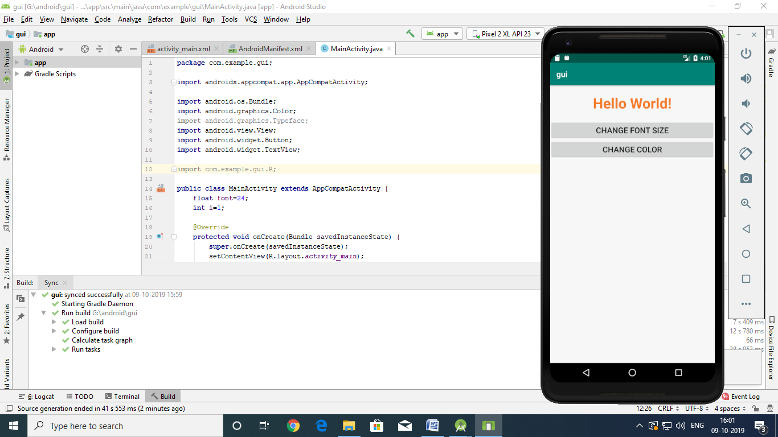

EX:NO:4 | SIMPLE APP FOR ARITHMETIC OPERATIONS
DATE:24-07-19

AIM:

Program for developing an Android Application using a Arithmetic

Description:

1)Open android studio and select new android project .
2)Give project name and select next
3) Choose the android version.Choose the lowest API 15:Android
4.3.0(IceCreamSandwish) and select next
4) Enter the package name.package name must be two word seprated by comma
and click finish
5)Go to package explorer in the left hand side.select our project.
6)Go to res folder and select layout.Double click the main.xml file
7)Now you can see the Arithmetic window.

MainActivity.java
package com.example.arithmetic;

import androidx.appcompat.app.AppCompatActivity;

import android.os.Bundle;
import android.service.autofill.TextValueSanitizer;
import android.view.View;
import android.widget.Button;
import android.widget.EditText;
import android.widget.TextView;

public class MainActivity extends AppCompatActivity {
private Button add;
private Button sub;
private Button mul;
private Button div;
private Button mod;
private TextView result;
private EditText num1;
private EditText num2;

@Override
protected void onCreate(Bundle savedInstanceState) {
super.onCreate(savedInstanceState);
setContentView(R.layout.activity_main);
add=(Button)findViewById(R.id.btnadd);
sub=(Button)findViewById(R.id.sub);
mul=(Button)findViewById(R.id.mul);
div=(Button)findViewById(R.id.div);
mod=(Button)findViewById(R.id.mod);
num1=(EditText)findViewById(R.id.num1);
num2=(EditText)findViewById(R.id.num2);
result=(TextView)findViewById(R.id.result);
add.setOnClickListener(new View.OnClickListener() {
@Override
public void onClick(View view) {
int n1=Integer.parseInt(num1.getText().toString());
int n2=Integer.parseInt(num2.getText().toString());
int add=n1+n2;
result.setText("result : "+ String.valueOf(add));
}
});
sub.setOnClickListener(new View.OnClickListener() {
@Override
public void onClick(View view) {
int n1=Integer.parseInt(num1.getText().toString());
int n2=Integer.parseInt(num2.getText().toString());
int sub=n1-n2;
result.setText("result : "+ String.valueOf(sub));
}
});
mul.setOnClickListener(new View.OnClickListener() {
@Override
public void onClick(View view) {
int n1=Integer.parseInt(num1.getText().toString());
int n2=Integer.parseInt(num2.getText().toString());
int mul=n1*n2;
result.setText("result : "+ String.valueOf(mul));
}
});
div.setOnClickListener(new View.OnClickListener() {
@Override
public void onClick(View view) {
int n1=Integer.parseInt(num1.getText().toString());
int n2=Integer.parseInt(num2.getText().toString());
int div=n1/n2;
result.setText("result : "+ String.valueOf(div));
}
});
mod.setOnClickListener(new View.OnClickListener() {
@Override
public void onClick(View view) {
int n1=Integer.parseInt(num1.getText().toString());
int n2=Integer.parseInt(num2.getText().toString());
int div=n1%n2;
result.setText("result : "+ String.valueOf(div));
}
});
}
}

Activity_main.html:

<?xml version="1.0" encoding="UTF-8"?>
<RelativeLayout
tools:context=".MainActivity"
android:layout_height="match_parent"
android:layout_width="match_parent"
xmlns:tools="http://schemas.android.com/tools" xmlns:app="http://schemas.android.com/apk/res-auto"
xmlns:android="http://schemas.android.com/apk/res/android">
<TextView
android:layout_height="wrap_content"
android:layout_width="wrap_content"
android:textSize="20dp"
android:layout_marginBottom="50dp"
android:text="Arithmetic Operator "
android:layout_marginTop="8dp"
android:layout_marginLeft="100dp"
android:id="@+id/title"/>
<EditText
android:layout_height="wrap_content"
android:layout_width="wrap_content"
android:layout_marginLeft="8dp"
android:id="@+id/num1"
android:layout_below="@+id/title"
android:inputType="number"
android:ems="10"
android:hint="enter a value"
android:layout_marginRight="200dp"/>
<EditText
android:layout_height="wrap_content"
android:layout_width="wrap_content"
android:layout_marginLeft="8dp"
android:id="@+id/num2"
android:layout_below="@+id/num1"
android:inputType="number"
android:ems="10"
android:hint="enter a value"
android:layout_marginRight="200dp"/>
<Button
android:layout_height="wrap_content"
android:layout_width="wrap_content"
android:layout_marginBottom="8dp"
android:text="Add"
android:layout_marginLeft="8dp"
android:id="@+id/btnadd"
android:layout_below="@+id/num2"
android:layout_marginRight="8dp"/>
<Button
android:layout_height="wrap_content"
android:layout_width="wrap_content"
android:layout_marginBottom="8dp"
android:text="subtract"
android:layout_marginLeft="100dp"
android:id="@+id/sub"
android:layout_below="@+id/num2"
android:layout_marginRight="8dp"/>
<Button
android:layout_height="wrap_content"
android:layout_width="wrap_content"
android:text="multiply"
android:layout_marginLeft="8dp"
android:id="@+id/mul"
android:layout_below="@+id/btnadd"
android:layout_marginRight="8dp"/>
<Button
android:layout_height="wrap_content"
android:layout_width="wrap_content"
android:text="divide"
android:layout_marginLeft="100dp"
android:id="@+id/div"
android:layout_below="@+id/sub"
android:layout_marginRight="8dp"/>
<Button
android:layout_height="wrap_content"
android:layout_width="wrap_content"
android:text="modulus"
android:layout_marginLeft="8dp"
android:id="@+id/mod"
android:layout_below="@+id/div"
android:layout_marginRight="8dp"/>
<TextView
android:layout_height="43dp"
android:layout_width="107dp"
android:textSize="20dp"
android:text="Result"
android:layout_marginTop="8dp"
android:layout_marginLeft="8dp"
android:id="@+id/result"
android:layout_below="@+id/mod"/>
</RelativeLayout>

OUTPUT:

ADD
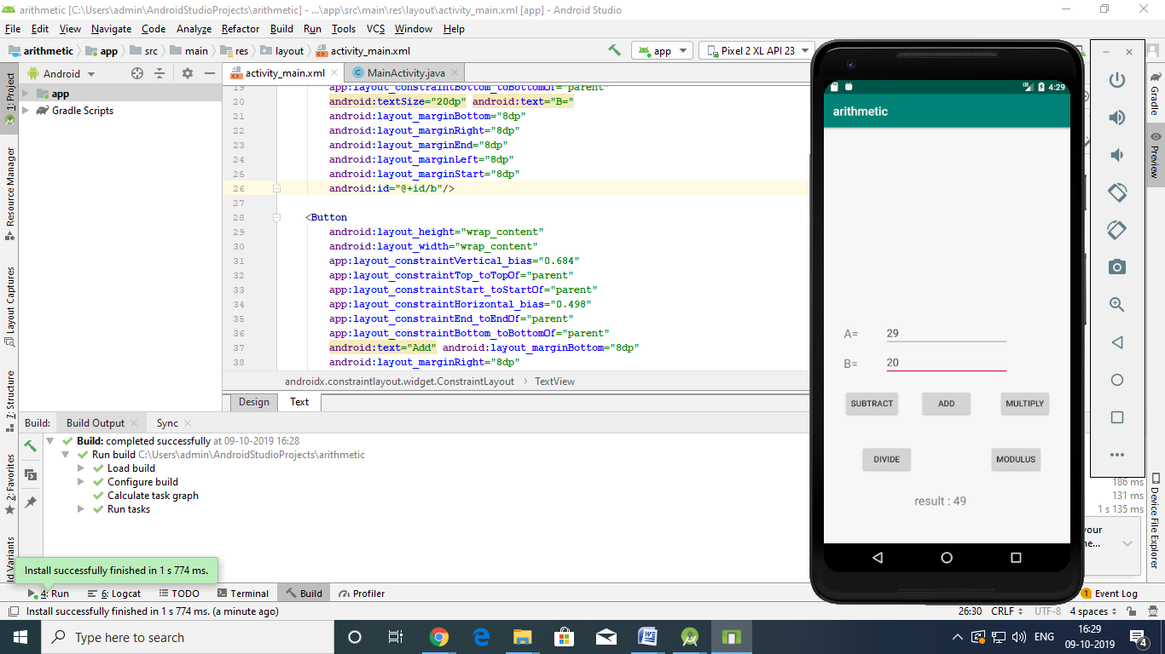

SUB
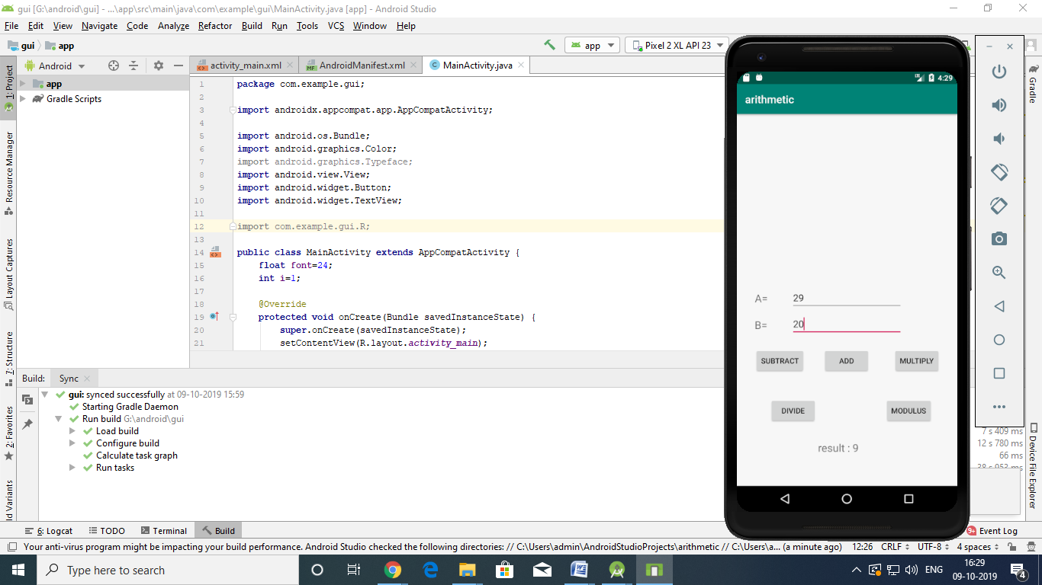

MULTIPLY

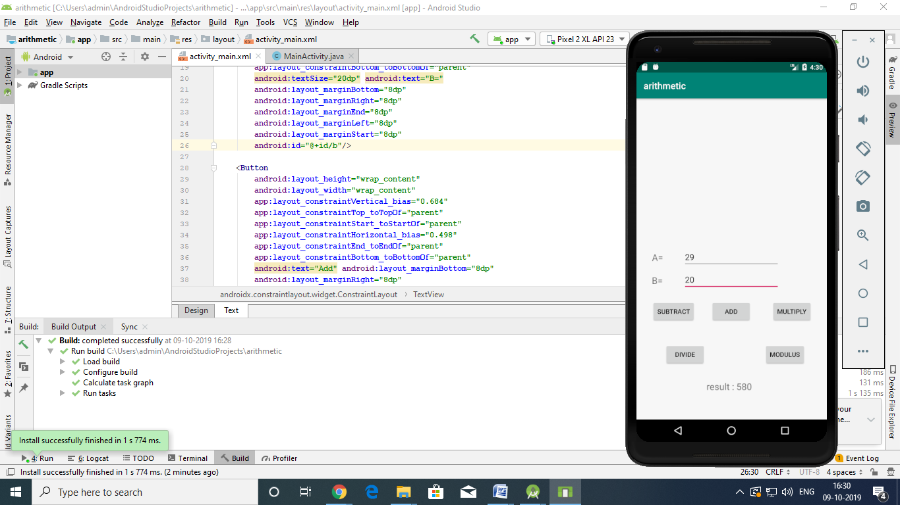

DIVIDE


MODULUS

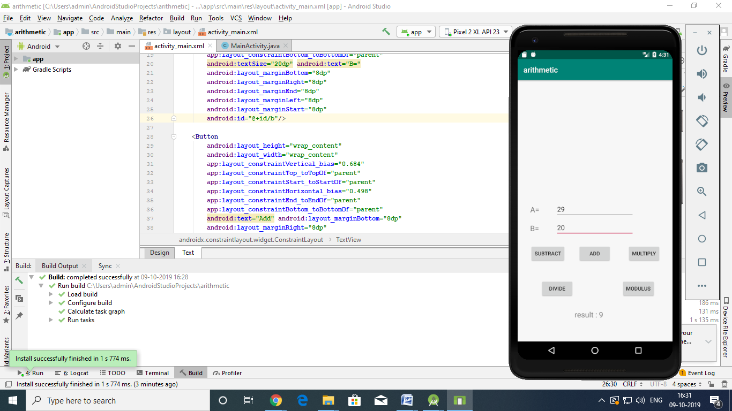

EX:NO:5 | IMPLEMENTATION OF LOGIN WEBPAGE
DATE:01-08-19

AIM:

Program for developing an Android Application using a Login Webpage

Description:

1)Open android studio and select new android project .
2)Give project name and select next
3) Choose the android version. Choose the lowest API 15:Android
4.3.0(IceCreamSandwish) and select next
4) Enter the package name. package name must be two word seprated by comma
and click finish
5)Go to package explorer in the left hand side. select our project.
6)Go to res folder and select layout. Double click the main.xml file
7) Go to res folder , Right click and select the layout /resource file to open a new
xml file
8) ) Go to package folder , Right click and select java class file to
open a new java file
9)Now you can see the Login Webpage window.

MAIN ACITIVITY:
package com.example.login;
import androidx.appcompat.app.AppCompatActivity;
import android.content.Intent;
import android.os.Bundle;
import android.view.View;
import android.widget.Button;
import com.example.login.R;
import com.example.login.web;
public class MainActivity extends AppCompatActivity {
@Override
protected void onCreate(Bundle savedInstanceState) {
Button login;
super.onCreate(savedInstanceState);
setContentView(R.layout.activity_main);
login = findViewById(R.id.login);
login.setOnClickListener(new View.OnClickListener() {
@Override
public void onClick(View view) {
Intent i = new Intent(MainActivity.this, web.class);
startActivity(i);
}
});
}
}

MAIN ACITIVITY:WEB

package com.example.login;
import android.os.Bundle;
import android.webkit.WebView;
import androidx.annotation.Nullable;
import androidx.appcompat.app.AppCompatActivity;
public class web extends AppCompatActivity {
WebView web;
@Override
protected void onCreate(@Nullable Bundle savedInstanceState) {
super.onCreate(savedInstanceState);
setContentView(R.layout.web);
web=findViewById(R.id.web_view);
web.loadUrl("https://www.google.com");
}
}

ACTIVITY MAIN:

<?xml version="1.0" encoding="UTF-8"?>
<RelativeLayout tools:context=".MainActivity" android:background="#C3A1E1"
android:layout_height="match_parent"
android:layout_width="match_parent" xmlns:tools="http://schemas.android.com/tools" xmlns:app="http://schemas.android.com/apk/res-auto" xmlns:android="http://schemas.android.com/apk/res/android">
<TextView
android:layout_height="wrap_content"
android:layout_width="wrap_content"
android:text="Login with webpage"
android:layout_centerHorizontal="true"
android:layout_marginTop="30dp"
android:textStyle="bold"
android:textSize="30dp"
android:textColor="#ffff"/>
<EditText
android:background="#ffff"
android:layout_height="wrap_content"
android:layout_width="match_parent"
android:layout_centerInParent="true"
android:layout_marginLeft="20dp"
android:layout_marginRight="20dp"
android:hint="username"
android:inputType="text"
android:id="@+id/edit_1"/>
<EditText
android:background="#ffff"
android:layout_height="wrap_content"
android:layout_width="match_parent"
android:layout_marginTop="20dp"
android:layout_centerInParent="true"
android:layout_marginLeft="20dp"
android:layout_marginRight="20dp"
android:hint="password"
android:inputType="textPassword"
android:id="@+id/edit_2"
android:layout_below="@id/edit_1"/>
<Button
android:background="#ED6C7A"
android:layout_height="wrap_content"
android:layout_width="match_parent"
android:text="login"
android:layout_marginTop="20dp"
android:layout_centerInParent="true"
android:layout_marginLeft="60dp"
android:layout_marginRight="60dp"
android:id="@+id/login"
android:layout_below="@id/edit_2"/>
</RelativeLayout>

ACITIVITY MAIN:WEB

<?xml version="1.0" encoding="UTF-8"?>
<LinearLayout android:layout_height="match_parent" android:layout_width="match_parent" android:orientation="vertical" xmlns:android="http://schemas.android.com/apk/res/android">
<WebView android:layout_height="match_parent" android:layout_width="match_parent" android:id="@+id/web_view"> </WebView>
</LinearLayout>

MAINFEST:

<?xml version="1.0" encoding="UTF-8"?>
<manifest package="com.example.login" xmlns:android="http://schemas.android.com/apk/res/android">
<uses-permission android:name="android.permission.INTERNET"/>
<application android:theme="@style/AppTheme" android:supportsRtl="true" android:roundIcon="@mipmap/ic_launcher_round" android:label="@string/app_name" android:icon="@mipmap/ic_launcher" android:allowBackup="true">
<activity android:name=".MainActivity">
<intent-filter>
<action android:name="android.intent.action.MAIN"/>
<category android:name="android.intent.category.LAUNCHER"/>
</intent-filter>
</activity>
<activity android:name=".web"/>
</application>
</manifest>

OUTPUT:

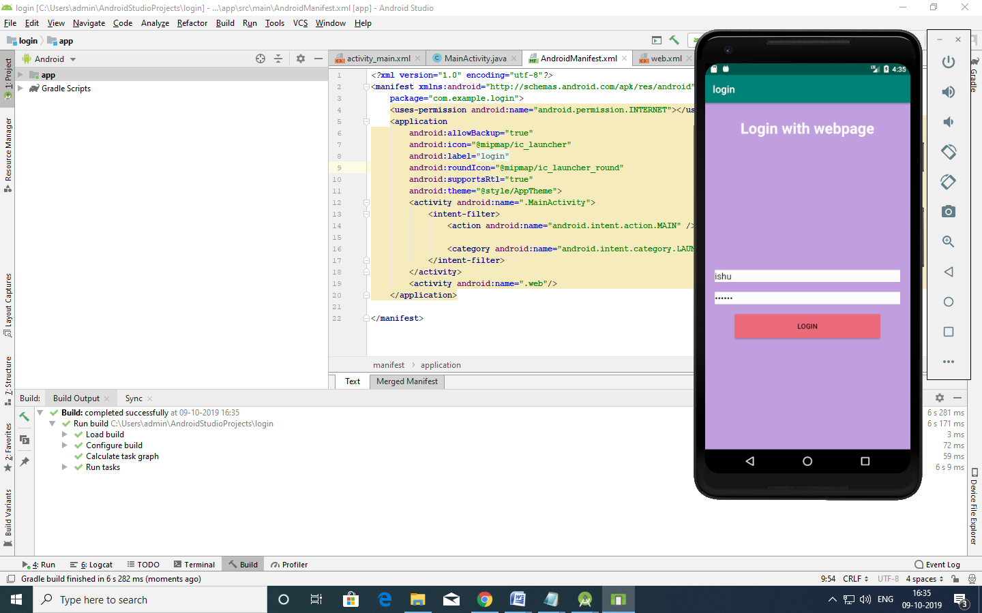

EX:NO:6 | SIMPLE APP FOR GALLERY VIEW
DATE:29-08-19

AIM:

Program for developing an Android Application using a Gallery Webpage

Description:

1)Open android studio and select new android project .
2)Give project name and select next
3) Choose the android version. Choose the lowest API 15:Android
4.3.0(IceCreamSandwish) and select next
4) Enter the package name. package name must be two word seprated by comma
and click finish
5)Go to package explorer in the left hand side. select our project.
6)Go to res folder and select layout. Double click the main.xml file
7) Go to res folder , Right click and select the layout /resource file to open a new
xml file
8) ) Go to package folder , Right click and select java class file to
open a new java file
9)Now you can see the Gallery Webpage window.

MAINACTIVITY:
package com.example.gallery;
import androidx.appcompat.app.AppCompatActivity;
import android.content.Intent;
import android.os.Bundle;
import android.view.View;
import android.widget.Button;
public class MainActivity extends AppCompatActivity {
Button b1;
@Override
protected void onCreate(Bundle savedInstanceState) {
super.onCreate(savedInstanceState);
setContentView(R.layout.main);
Button b1=(Button)findViewById(R.id.b1);
b1.setOnClickListener(new View.OnClickListener() {
@Override
public void onClick(View view) {
Intent i= new Intent(MainActivity.this, gal.class);
startActivity(i);
}
});

}
}
GAL.JAVA
package com.example.gallery;
import android.os.Bundle;
import android.widget.Button;
import androidx.annotation.Nullable;
import androidx.appcompat.app.AppCompatActivity;

public class gal extends AppCompatActivity {
Button b1;
@Override
protected void onCreate(@Nullable Bundle savedInstanceState) {
super.onCreate(savedInstanceState);
setContentView(R.layout.gal);
}
}
ACTIVITY MAIN.XML
<?xml version="1.0" encoding="utf-8" ?>

<LinearLayout
xmlns:android="http://schemas.android.com/apk/res/android" android:orientation="vertical"
android:layout_width="match_parent"
android:layout_height="match_parent">

<Button
android:layout_width="wrap_content"
android:layout_height="wrap_content"
android:text="Gallery"
android:layout_marginTop="200dp"
android:layout_marginLeft="150dp"
android:id="@+id/b1" />

</LinearLayout>

GAL.XML
<?xml version="1.0" encoding="utf-8" ?>

<LinearLayout
xmlns:android="http://schemas.android.com/apk/res/android" android:orientation="vertical"
android:layout_width="match_parent"
android:layout_height="match_parent">

<ScrollView
android:layout_width="match_parent"
android:layout_height="match_parent">

<LinearLayout
android:layout_width="match_parent"
android:layout_height="match_parent"
android:orientation="vertical">

<LinearLayout
android:layout_width="match_parent"
android:layout_height="250dp">

<ImageView
android:layout_width="match_parent
" android:layout_height="match_parent"
android:src="@drawable/img" />

</LinearLayout>

<LinearLayout
ndroid:layout_width="match_parent"
android:layout_height="250dp">

<ImageView
android:layout_width="match_parent"
android:layout_height="match_parent"
android:src="@drawable/img1" />

</LinearLayout>

<LinearLayout
android:layout_width="match_parent"
android:layout_height="250dp">

<ImageView
android:layout_width="match_parent"
android:layout_height="match_parent"
android:src="@drawable/img3" />

</LinearLayout>

<LinearLayout
android:layout_width="match_parent"
android:layout_height="250dp">

<ImageView
android:layout_width="match_parent"
android:layout_height="match_parent"
android:src="@drawable/img2" />

</LinearLayout>

</LinearLayout>

</ScrollView>

</LinearLayout>

MAINFEST:
<?xml version="1.0" encoding="utf-8" ?>

<manifest
xmlns:android="http://schemas.android.com/apk/res/android" package="com.example.gallery">

<application

android:allowBackup="true"

android:icon="@mipmap/ic_launcher"

android:label="@string/app_name"

android:roundIcon="@mipmap/ic_launcher_round

" android:supportsRtl="true"

android:theme="@style/AppTheme">

<activity android:name=".MainActivity">

<intent-filter>

<action android:name="android.intent.action.MAIN" />

<category android:name="android.intent.category.LAUNCHER" />

</intent-filter>

</activity>

<activity android:name=".gal" />

</application>

</manifest>
OUTPUT:

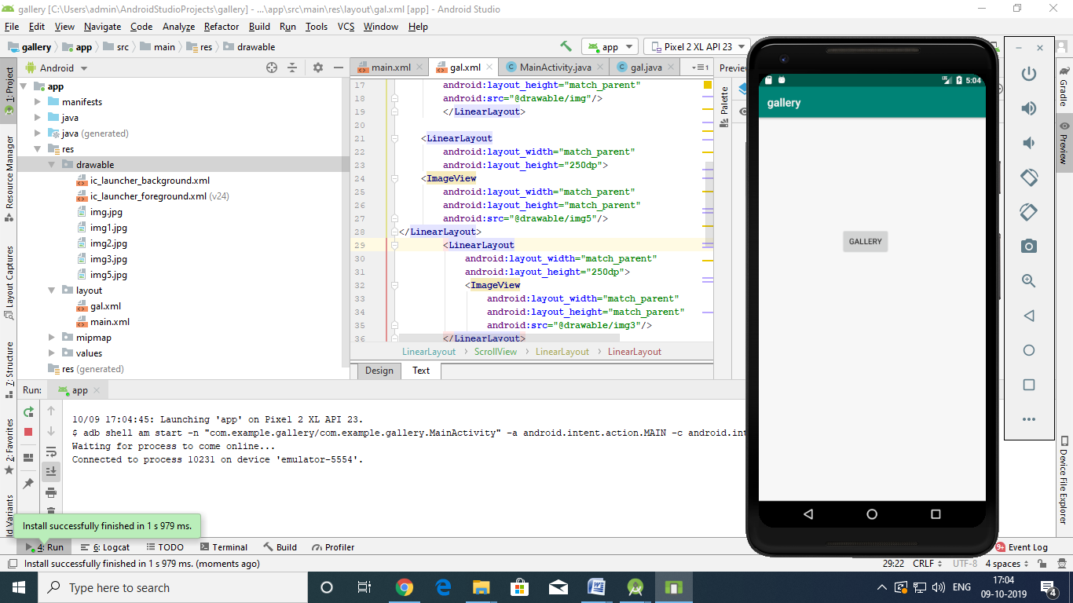

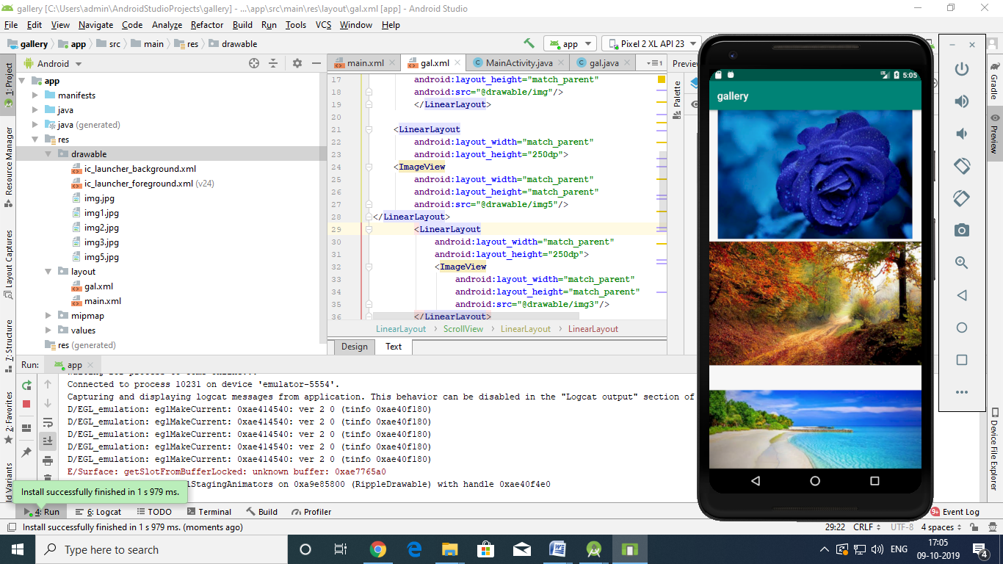

EX:NO:7 | ANDROID APPLICATION TO DISPLAY DATE AND TIME.
DATE:06-09-19

AIM:

Program for developing an Android Application using a Date And Time.

Description:

1)Open android studio and select new android project .
2)Give project name and select next
3) Choose the android version.Choose the lowest API 15:Android
4.3.0(IceCreamSandwish) and select next
4) Enter the package name.package name must be two word seprated by comma
and click finish
5)Go to package explorer in the left hand side.select our project.
6)Go to res folder and select layout.Double click the main.xml file
7)Now you can see the Date And Time window.

MAIN ACTIVITY:
package com.example.graphics;
import androidx.appcompat.app.AppCompatActivity;
import android.app.Activity;
import android.content.Context;
import android.graphics.Canvas;
import android.graphics.Color;
import android.graphics.Paint;
import android.view.View;
import android.os.Bundle;
public class MainActivity extends Activity {
@Override
protected void onCreate(Bundle savedInstanceState) {
super.onCreate(savedInstanceState);
setContentView(new myview(this));
}

private class myview extends View
{
public myview(Context context)
{
super(context);
}
protected void OnDraw(Canvas canvas)
{
super.onDraw(canvas);
Paint paint=new Paint();
paint.setTextSize(40);
paint.setColor(Color.GREEN);
canvas.drawText("Circle", 55,30,paint);
paint.setColor(Color.RED);
canvas.drawCircle(100,150,100,paint);
paint.setColor(Color.GREEN);
canvas.drawText("Rectangle",255,30,paint);
paint.setColor(Color.YELLOW);
canvas.drawRect(250,50,400,350, paint);
paint.setColor(Color.GREEN);
canvas.drawText("Square",55,430, paint);
paint.setColor(Color.BLUE);
canvas.drawRect(50,450,150,550,paint);
paint.setColor((Color.GREEN));
canvas.drawText("Line",255,430,paint);
paint.setColor(Color.CYAN);
canvas.drawLine(250,500,350,500,paint);
}
}
}

ACTIVITY MAIN:
<?xml version="1.0" encoding="UTF-8" ?>

<LinearLayout tools:context=".MainActivity"
android:orientation="vertical"
android:layout_height="match_parent"
android:layout_width="match_parent"
xmlns:tools="http://schemas.android.com/tools" xmlns:app="http://schemas.android.com/apk/res-auto" xmlns:android="http://schemas.android.com/apk/res/android">

<TextView
android:layout_height="wrap_content"
android:layout_width="match_parent"
android:textStyle="bold"
android:textSize="20sp"
android:gravity="center"
android:layout_margin="20sp"
android:text="HOPE"
android:id="@+id/textview1" />

<Button
android:layout_height="wrap_content"
android:layout_width="match_parent"
android:textSize="20sp"
android:gravity="center"
android:text="change font size"
android:id="@+id/button1" />

<Button
android:layout_height="wrap_content"
android:layout_width="match_parent"
android:textSize="20sp"
android:gravity="center"
android:text="change color"
android:id="@+id/button2" />

</LinearLayout>

OUTPUT:

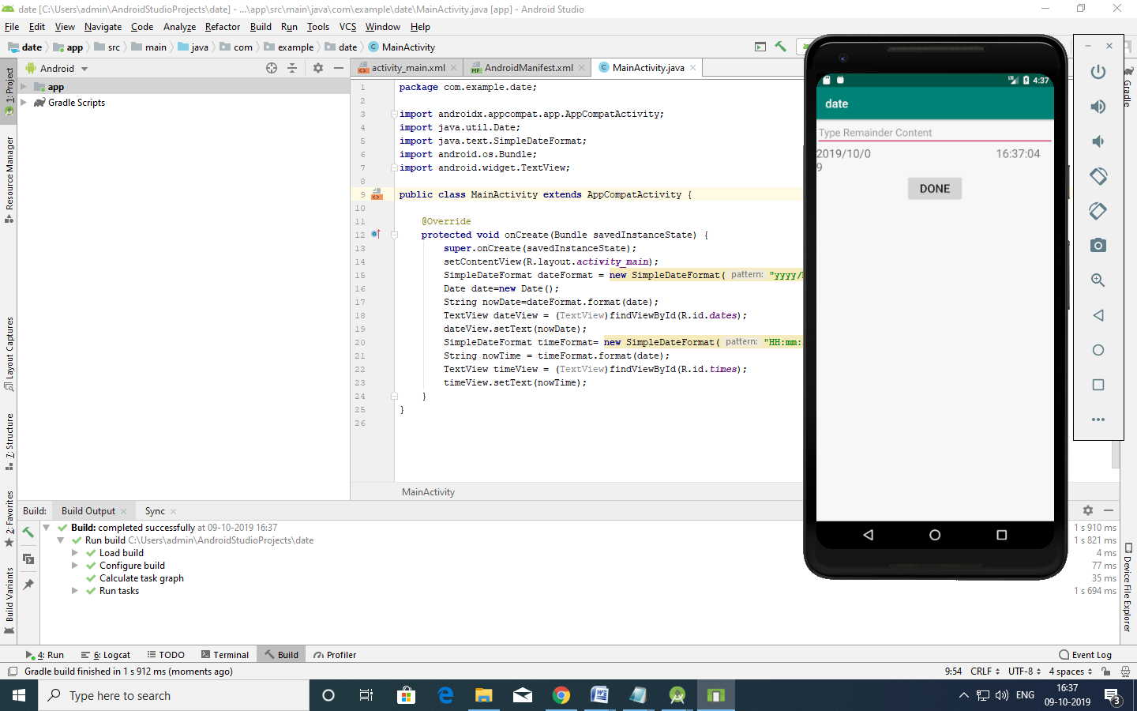

EX:NO:8 | ANDROID APPLICATION FOR IMPLEMENTING GRAPHICS
DATE:14-09-19

AIM:

Program for developing an Android Application using a Graphics.

Description:

1)Open android studio and select new android project .
2)Give project name and select next
3) Choose the android version.Choose the lowest API 15:Android
4.3.0(IceCreamSandwish) and select next
4) Enter the package name.package name must be two word seprated by comma
and click finish
5)Go to package explorer in the left hand side.select our project.
6)Go to res folder and select layout.Double click the main.xml file
7)Now you can see the Graphics window.

MAINACTIVITY:
package com.example.graphics;

import androidx.appcompat.app.AppCompatActivity;
import android.os.Bundle;
import android.content.Context;
import android.graphics.Canvas;
import android.graphics.Color;
import android.graphics.Paint;
import android.view.View;

public class MainActivity extends AppCompatActivity {

@Override
protected void onCreate(Bundle savedInstanceState) {
super.onCreate(savedInstanceState);
setContentView(new myview(this));
}
private class myview extends View
{
public myview(Context context)
{
super(context);
}
@Override
protected void onDraw(Canvas canvas)
{
super.onDraw(canvas);
Paint paint = new Paint();
paint.setTextSize(40);
paint.setColor(Color.GREEN);
canvas.drawText("Circle",55,30,paint);
paint.setColor(Color.RED);
canvas.drawCircle(100,150,100,paint);
paint.setColor(Color.GREEN);
canvas.drawText("Rectangle",255,30,paint);
canvas.drawRect(250,50,400,350,paint);
paint.setColor(Color.CYAN);
canvas.drawText("square",55,430,paint);
canvas.drawRect(50,450,150,550,paint);
paint.setColor(Color.GREEN);
canvas.drawText("Line",255,430,paint);
canvas.drawLine(250,500,350,500,paint);

}
}
}
ACTIVITY MAIN:
<?xml version="1.0" encoding="UTF-8" ?>

<AbsoluteLayout
tools:context=".MainActivity"
android:layout_height="match_parent"
android:layout_width="match_parent"
xmlns:tools="http://schemas.android.com/tools" xmlns:app="http://schemas.android.com/apk/res-auto" xmlns:android="http://schemas.android.com/apk/res/android">

<TextView
android:layout_height="wrap_content"
android:layout_width="wrap_content"
android:textColor="@color/colorPrimaryDark"
android:textSize="40dp"
android:text="Employee details"
android:layout_y="10dp"
android:layout_x="50dp"
android:id="@+id/head" />

<TextView
android:layout_height="wrap_content"
android:layout_width="wrap_content" android:textColor="@android:color/holo_orange_dark"
android:textSize="20dp"
android:text="Employee id"
android:layout_y="100dp"
android:layout_x="20dp"
android:id="@+id/eid" />

<TextView
android:layout_height="wrap_content"
android:layout_width="wrap_content" android:textColor="@android:color/holo_orange_dark"
android:textSize="20dp"
android:text="Employee Name"
android:layout_y="150dp"
android:layout_x="20dp"
android:id="@+id/ename" />

<EditText
android:layout_height="40dp"
android:layout_width="150dp"
android:layout_y="100dp"
android:layout_x="200dp"
android:id="@+id/idval" />

<EditText
android:layout_height="40dp"
android:layout_width="150dp"
android:layout_y="150dp"
android:layout_x="200dp"
android:id="@+id/nameval" />

<Button
android:layout_height="wrap_content"
android:layout_width="wrap_content"
android:text="ADD"
android:layout_y="300dp"
android:layout_x="70dp"
android:id="@+id/b1" />

<Button
android:layout_height="wrap_content"
android:layout_width="wrap_content"
android:text="List"
android:layout_y="300dp"
android:layout_x="200dp"
android:id="@+id/b2" />
</AbsoluteLayout>

OUTPUT:

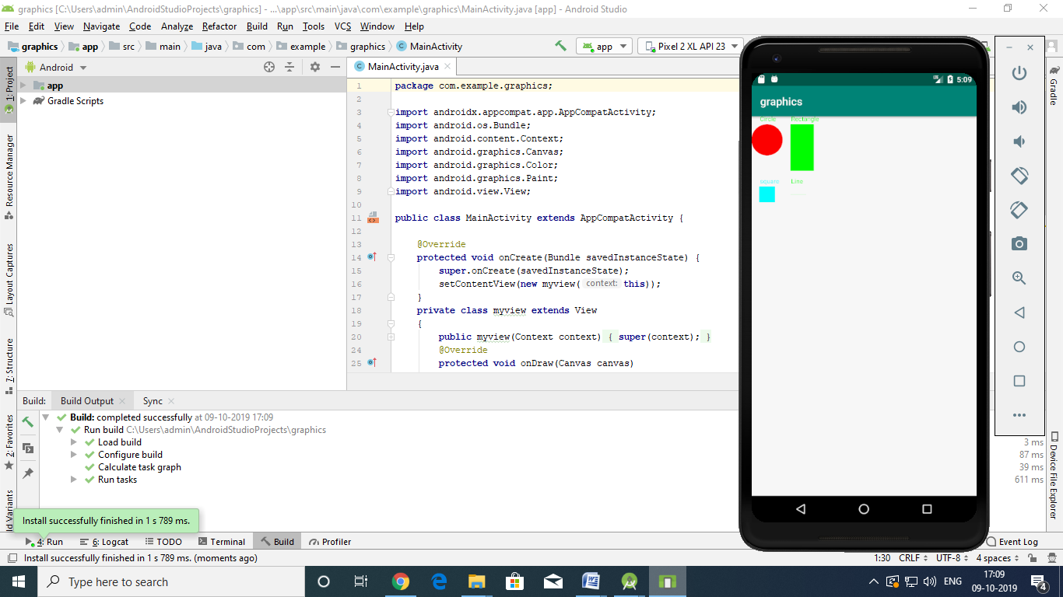

EX:NO:9 | SIMPLE APP FOR LOGIN WITH VALIDATION
DATE:20-09-19

AIM:

Program for developing an Android Application using a Login With Valaidation Webpage.

Description:

1)Open android studio and select new android project .
2)Give project name and select next
3) Choose the android version. Choose the lowest API 15:Android
4.3.0(IceCreamSandwish) and select next
4) Enter the package name. package name must be two word seprated by comma
and click finish
5)Go to package explorer in the left hand side. select our project.
6)Go to res folder and select layout. Double click the main.xml file
7) Go to res folder , Right click and select the layout /resource file to open a new
xml file
8) ) Go to package folder , Right click and select java class file to
open a new java file
9)Now you can see the Login With Validation Webpage window.

ACTIVITY MAIN:
<?xml version="1.0" encoding="utf-8"?>
<RelativeLayout xmlns:android="http://schemas.android.com/apk/res/android"
xmlns:app="http://schemas.android.com/apk/res-auto"
xmlns:tools="http://schemas.android.com/tools"
android:layout_width="match_parent"
android:layout_height="match_parent"
tools:context=".MainActivity">
<TextView
android:id="@+id/name"
android:layout_width="wrap_content"
android:layout_height="wrap_content"
android:layout_marginLeft="30dp"
android:layout_marginTop="30dp"
android:gravity="center"
android:text="Name"
android:textSize="20dp" />
<EditText
android:id="@+id/etname"
android:layout_width="wrap_content"
android:layout_height="wrap_content"
android:layout_marginLeft="130dp"
android:layout_marginTop="20dp"
android:ems="10"
android:hint="use only alphabests"
android:textSize="20dp"></EditText>
<TextView
android:id="@+id/pass"
android:layout_width="wrap_content"
android:layout_height="wrap_content"
android:layout_marginLeft="30dp"
android:layout_marginTop="100dp"
android:layout_marginBottom="0dp"
android:gravity="center"
android:text="Password"
android:textSize="20dp" />
<EditText
android:id="@+id/etpass"
android:layout_width="wrap_content"
android:layout_height="wrap_content"
android:layout_marginLeft="130dp"
android:layout_marginTop="90dp"
android:ems="10"
android:hint="max of 6 character"
android:inputType="textPassword"
android:textSize="20dp"></EditText>
<Button
android:id="@+id/btlogin"
android:layout_width="wrap_content"
android:layout_height="wrap_content"
android:layout_marginLeft="140dp"
android:layout_marginTop="150dp"
android:layout_marginBottom="0dp"
android:gravity="center"
android:text="login"
android:textSize="20dp" />
</RelativeLayout>

MAINACTIVITY:
package com.example.login;
import androidx.appcompat.app.AppCompatActivity;
import android.content.Intent;
import android.os.Bundle;
import android.view.View;
import android.widget.Button;
import android.widget.EditText;
import android.widget.Toast;
public class MainActivity extends AppCompatActivity {
private EditText Name;
private EditText Password;
private Button Login;
@Override
protected void onCreate(Bundle savedInstanceState) {
super.onCreate(savedInstanceState);
setContentView(R.layout.activity_main);
Name = (EditText)findViewById(R.id.etname);
Password = (EditText)findViewById(R.id.etpass);
Login = (Button)findViewById(R.id.btlogin);
Login.setOnClickListener(new View.OnClickListener() {
@Override
public void onClick(View view) {
String n=Name.getText().toString();
String p=Password.getText().toString();
if(n.equals("Admin") && p.equals("12345678")){
Toast.makeText(getApplicationContext(), "Login successful", Toast.LENGTH_SHORT).show();
Intent intent = new Intent(MainActivity.this, logout.class);
startActivity(intent);
}else{
Toast.makeText(MainActivity.this, "Login Failed", Toast.LENGTH_SHORT).show();
}
}
});
}
}
MAINFEST:
<?xml version="1.0" encoding="utf-8"?>
<manifest xmlns:android="http://schemas.android.com/apk/res/android"
package="com.example.login">
<application
android:allowBackup="true"
android:icon="@mipmap/ic_launcher"
android:label="@string/app_name"
android:roundIcon="@mipmap/ic_launcher_round"
android:supportsRtl="true"
android:theme="@style/AppTheme">
<activity android:name=".MainActivity">
<intent-filter>
<action android:name="android.intent.action.MAIN" />
<category android:name="android.intent.category.LAUNCHER" />
</intent-filter>
</activity>
<activity android:name=".logout"/>
</application>
</manifest>

MAINACTIVITY:JAVA
package com.example.login;
import android.content.Intent;
import android.os.Bundle;
import android.view.View;
import android.widget.Button;
import android.widget.Toast;
import androidx.annotation.Nullable;
import androidx.appcompat.app.AppCompatActivity;
public class logout extends AppCompatActivity {
private Button Logout;
@Override
protected void onCreate(Bundle savedInstanceState) {
super.onCreate(savedInstanceState);
setContentView(R.layout.logout);
Logout = (Button) findViewById(R.id.btlogout);
Logout.setOnClickListener(new View.OnClickListener() {
@Override
public void onClick(View view) {
Intent intent = new Intent(logout.this, MainActivity.class);
startActivity(intent);
// startActivity(new Intent(SecondActivity.this, MainActivity.class));
//Toast.makeText(MainActivity.this, "Logged out Successful", Toast.LENGTH_SHORT).show();
}
});
}
}

ACTIVITY MAIN.XML
<?xml version="1.0" encoding="utf-8"?>
<RelativeLayout xmlns:android="http://schemas.android.com/apk/res/android"
android:layout_width="match_parent"
android:layout_height="match_parent">
<TextView
android:id="@+id/msg"
android:layout_width="wrap_content"
android:layout_height="wrap_content"
android:layout_centerInParent="true"
android:layout_marginLeft="40dp"
android:layout_marginTop="150dp"
android:layout_marginBottom="0dp"
android:text="Hello ! Welcome to our page."
android:textSize="25dp" />
<Button
android:id="@+id/btlogout"
android:layout_width="wrap_content"
android:layout_height="wrap_content"
android:layout_marginLeft="150dp"
android:layout_marginTop="450dp"
android:layout_marginBottom="5dp"
android:gravity="center"
android:text="LOGOUT"
android:textSize="20dp" />
</RelativeLayout>
OUTPUT:
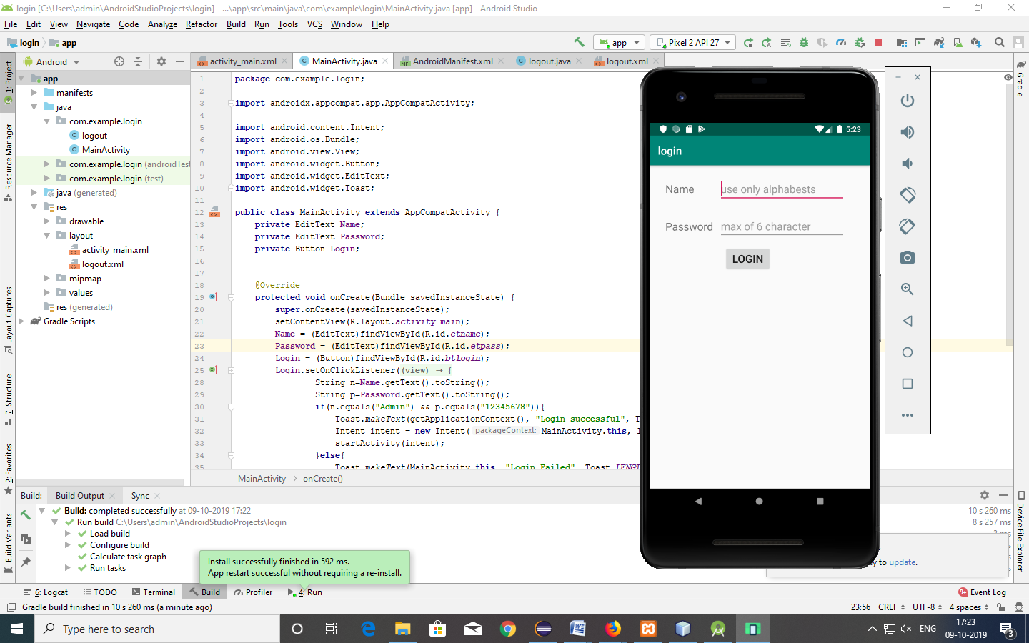
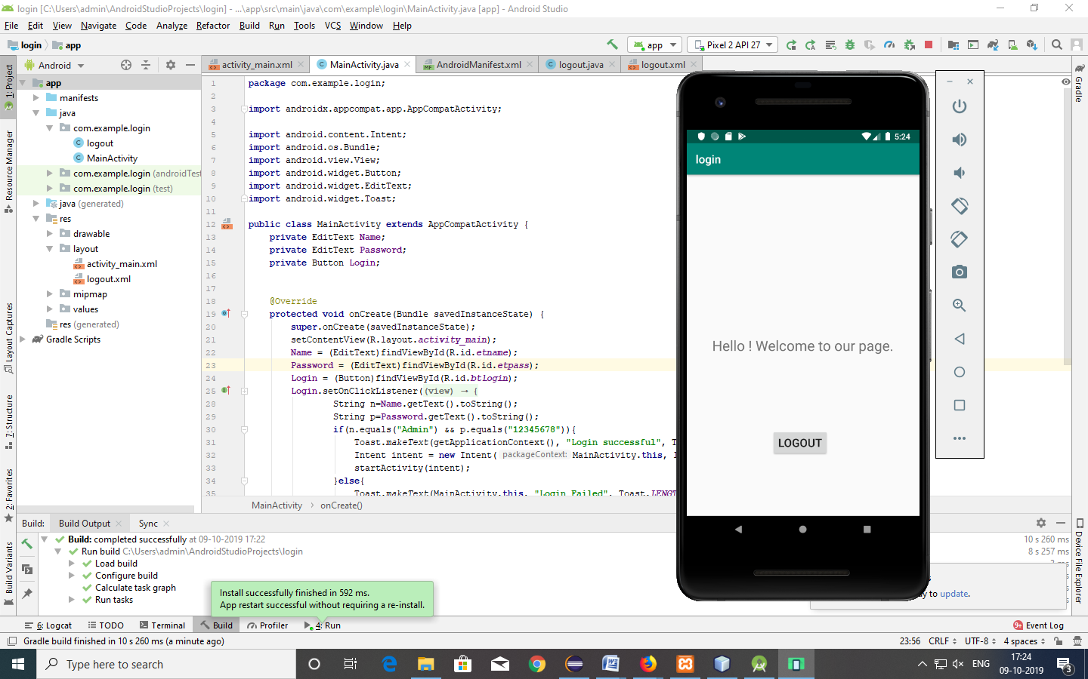
EX:NO:10 | ANDROID APPLICATION USING ABSOLUTE LAYOUT
DATE:28-09-19

AIM:

Program for developing an Android Application using a Absolute Layout.

Description:

1)Open android studio and select new android project .
2)Give project name and select next
3) Choose the android version.Choose the lowest API 15:Android
4.3.0(IceCreamSandwish) and select next
4) Enter the package name.package name must be two word seprated by comma
and click finish
5)Go to package explorer in the left hand side.select our project.
6)Go to res folder and select layout.Double click the main.xml file
7)Now you can see the Absolute Layout window.

ACTIVITY MAIN.XML
<?xml version="1.0" encoding="utf-8"?>
<AbsoluteLayout xmlns:android="http://schemas.android.com/apk/res/android"
xmlns:app="http://schemas.android.com/apk/res-auto"
xmlns:tools="http://schemas.android.com/tools"
android:layout_width="match_parent"
android:layout_height="match_parent"
tools:context=".MainActivity">
<TextView android:id="@+id/head"
android:layout_width="wrap_content"
android:layout_height="wrap_content"
android:layout_x="50dp"
android:layout_y="10dp"
android:text="Employee details"
android:textSize="40dp"
android:textColor="@color/colorPrimaryDark"
/>
<TextView android:id="@+id/eid"
android:layout_width="wrap_content"
android:layout_height="wrap_content"
android:layout_x="20dp"
android:layout_y="100dp"
android:text="Employee id"
android:textSize="20dp"
android:textColor="@android:color/holo_orange_dark"
/>
<TextView android:id="@+id/ename"
android:layout_width="wrap_content"
android:layout_height="wrap_content"
android:layout_x="20dp"
android:layout_y="150dp"
android:text="Employee Name"
android:textSize="20dp"
android:textColor="@android:color/holo_orange_dark"
/>
<EditText android:id="@+id/idval"
android:layout_width="150dp"
android:layout_height="40dp"
android:layout_x="200dp"
android:layout_y="100dp"
/>
<EditText android:id="@+id/nameval"
android:layout_width="150dp"
android:layout_height="40dp"
android:layout_x="200dp"
android:layout_y="150dp"
/>
<Button android:id="@+id/b1"
android:layout_width="wrap_content"
android:layout_height="wrap_content"
android:text="ADD"
android:layout_x="100dp"
android:layout_y="250dp"
/>
<TextView
android:id="@+id/t1"
android:layout_width="wrap_content"
android:layout_height="wrap_content"
android:layout_x="80dp"
android:layout_y="320dp"
android:textStyle="bold"
android:textSize="30dp"/>
</AbsoluteLayout>

MAINACTIVITY:JAVA
package com.example.absolute;
import androidx.appcompat.app.AppCompatActivity;
import android.os.Bundle;
import android.view.View;
import android.widget.Button;
import android.widget.TextView;
public class MainActivity extends AppCompatActivity {
@Override
protected void onCreate(Bundle savedInstanceState) {
super.onCreate(savedInstanceState);
setContentView(R.layout.activity_main);
Button b1=findViewById(R.id.b1);
final TextView t1=findViewById(R.id.t1);
b1.setOnClickListener(new View.OnClickListener() {
@Override
public void onClick(View view) {
t1.setText("Added successfully");
}
}); }
OUTPUT:
